Index code

/**

 * @format

 */

import React, {Component} from 'react';

import {AppRegistry} from 'react-native';

//import App from './App';

import {name as appName} from './app.json';

import BasicFlatlistData from './componets/basicFlatlistData';

AppRegistry.registerComponent(appName, () => BasicFlatlistData) ;

Code flatlistdata

var flatlistData =[

    {

        "key" : "qweryty123",

        "name" : "nasi goreng",

        "imageUrl": "https://1.bp.blogspot.com/-Pf4ucigP0kk/XdwOQuoPBMI/AAAAAAAAcB0/iSaAlW8zY_QPkB3pFCOYkRyAU6XIq7hCgCLcBGAsYHQ/s1600/Nasi%2BAyam%2BKhas%2BSemarang.jpg",

        "description" : "nasi goreng serba ada",

        "link":"NASI GORENG SEHARGA Rp10.000"

    },

    {

        "key" : "qweryty1234",

        "name" : "nasi kucing",

        "imageUrl":"https://encrypted-tbn0.gstatic.com/images?q=tbn:ANd9GcSjHzHFZi0WV3c9O6WMsg8Q1xEjwlUD6yXjaHoyj5GLVaIAJ_I&s",

        "description" : "nasi kucing serba ada",

        "link":"NASI KUCING SEHARGA Rp5.000"

    },

    {

        "key" : "qweryty12345",

        "name" : "nasi uduk",

        "imageUrl":"https://encrypted-tbn0.gstatic.com/images?q=tbn:ANd9GcTYX8irmcRvNgemdT422bGGWygcaZjULGlPME026-_LN5WfmQE&s",

        "description" : "nasi uduk serba ada",

        "link":"NASI UDUK SEHARGA Rp7.000"

    },

    {

        "key" : "qweryty123456",

        "name" : "nasi samyang",

        "imageUrl":"https://encrypted-tbn0.gstatic.com/images?q=tbn:ANd9GcTYX8irmcRvNgemdT422bGGWygcaZjULGlPME026-_LN5WfmQE&s",

        "description" : "nasi samyang serba ada",

        "link":"NASI SAMYANG SEHARGA Rp15.000"

    },

    {

        "key" : "qweryty1234567",

        "name" : "nasi lele",

        "imageUrl":"https://encrypted-tbn0.gstatic.com/images?q=tbn%3AANd9GcR1Qr0TnTkLOvAnHdH9Cs4xlZ3rPnNl5pmQiA&usqp=CAU",

        "description" : "nasi lele serba ada",

        "link":"NASI LELE SEHARGA Rp12.000"

    },

    {

        "key" : "qweryty12345678",

        "name" : "nasi sate",

        "imageUrl":"https://encrypted-tbn0.gstatic.com/images?q=tbn%3AANd9GcS80VjypGHAY8vdWAbq0-gUHE9sRwlX8vN_7g&usqp=CAU",

        "description" : "nasi sate serba ada",

        "link":"NASI SATE SEHARGA Rp20.000"

    }

];

module.exports= flatlistData;

header code

import React from 'react';

import {StyleSheet, Text, View} from 'react-native';

export default function Header(){

    return (

        <View style={styles.header}>

        <Text style={styles.title}>Aplikasi menu makan</Text>

        </View>

    )

}

const styles = StyleSheet.create({

header: {

    height: 80,

    paddingTop: 10,

    backgroundColor: 'blue'

    },

title:{

    textAlign: 'center',

    color: 'yellow',

    fontSize: 40,

    fontWeight: 'bold'

}

});

Basic flatlist data code

import React, { Component} from 'react';

import{AppRegistry,StyleSheet, Text, View, Vibration, FlatList,Image,Button,Modal,TouchableOpacity} from 'react-native';

import flatlistData from '../data/flatlisData';

import Header from '../componets/header';

class FlatListItem extends Component{

    constructor(){

        super();

        this.state={

            show:false

        }

    }

    render(){

        return(

            <View style={{

                flex:1,

                flexDirection:'column'

            }}>

            <View style={{flex:1,

                flexDirection:'row',

            // backgroundColor: this.props.index% 2 ==0 ?'yellow':'red'

             backgroundColor:'red'}}>

                 <Image

                 source ={{uri:this.props.item.imageUrl}}

                 style={{width:100, height:100, margin:5 }}>

                 </Image>

                 <View style={{

                     flex:1,

                     flexDirection:"column"

                 }}>

                     <TouchableOpacity onPress={()=> {this.setState({show:true})} }>

                <Text style={styles.FlatListItem}> {this.props.item.name} </Text>

                <Modal

                transparent={true}

                visible={this.state.show}

                >

                    <View style={{backgroundColor:"#000000aa",flex:1}}>

                        <View style={{backgroundColor:"red", margin:50, padding:40, borderRadius:10, flex:1}}>

                            <Text style={{textAlign:"justify", fontSize:15, color:"yellow"}}>

                                {this.props.item.link}

                            </Text>

                            <Button title="Kembali" onPress={()=> {this.setState({show:false})}}/>

                        </View>

                    </View>

                </Modal>

                </TouchableOpacity>

                <Text style={styles.FlatListItem}> {this.props.item.description}</Text>

                <Button title="review" onPress={()=> {this.setState({show:true})}}/>

            </View>

            </View>

            <View

            style={{

                height:1,

                backgroundColor:'white'

            }}>

            </View>

            </View>

        )

    }

}

const styles = StyleSheet.create({

FlatListItem:{

    color:'black',

    padding: 10,

    fontSize: 20,

    fontWeight:'bold'

}

});

export default class BasicFlatlistData extends Component {

    render(){

        return(

            <View style={{flex:1, marginTop:22, backgroundColor:'black'}}>

                <Header/>

                <FlatList

                data={flatlistData}

                renderItem={({item,index}) =>{

                    return (

                        <FlatListItem item={item} index={index}></FlatListItem>

                    );

                } }

                >

                </FlatList>

            </View>

        )

    }

}

Hasilnya

4.1

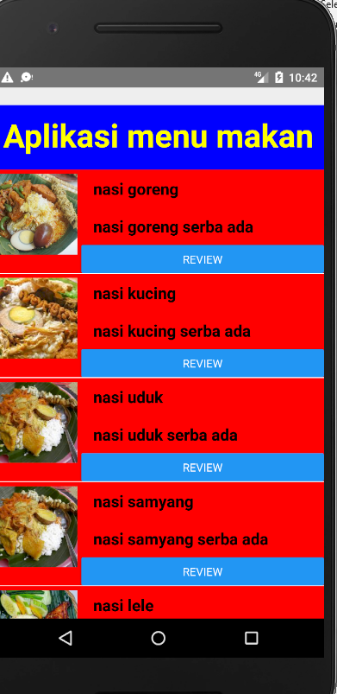

Hasil 4,2

